Getting Students Logged In (Initial Sign-In)
**Note: students must first complete the digital consent process to activate
their accounts before they are able to do these steps and log in**

First Time Login
Logging Into Chrome
Accessing GSuite Apps

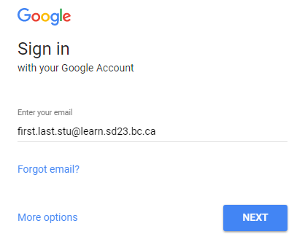
First Time Login
- Have your students open a Chrome Browser.
- Have them click on the ‘gmail’ link in the top right corner or go to accounts.google.com/login
- Note: If someone is already logged in, you’ll need to log that person out.
- Student username is first.last.stu@learn.sd23.bc.ca
- The initial temporary student password is Learn#23
(note: password is case sensitive)
- Students will be prompted to change their passwords upon logging in.
- Note: students should be able to change their passwords to their usual SD23 network password, however, passwords must be at least 8 characters long (so they may need to pick a different password).

FAQ: What if my current SD23 network password doesn’t meet the 8 character requirement and I’d like my SD23 network password and SD23 GSuite password to be the same?
- Simply enter an 8 character password for your GSuite account. Once you’re logged in, hit CTRL+ALT+DEL on your computer and click “Change Password”. When you update your password it will make this password the same for both your SD23 Network account and your SD23 GSuite account.

Logging Into Chrome

- Once in a Chrome Browser, have your students click on the ‘person’ icon in the top right corner and click ‘Sign in to Chrome’.

- Students will then be prompted to enter their SD23 GSuite username and password (remember their usernames are firstname.lastname.stu@learn.sd23.bc.ca)

- Students will then need to link their account to Chrome by clicking ‘Link Data’, and then click ‘OK, got it’ to finalize the sync.

**Students should notice the ‘person’ icon has now changed to their name, and after a few seconds, all their Chrome bookmarks and extensions should now be showing**

Accessing GSuite Apps
As part of the Google Apps for Education environment students have access to a suite of free Google Apps. If you would like to have your students explore/access the available Google Apps please have them follow the following steps:

- Select the Apps grid (top left icon in your toolbar).
- Note: if you don’t see your Apps grid, right click on your toolbar and make sure that “Short Apps shortcut” is checked-on.

- Click on any of the available icons to explore/enter.
