Mr. Marks 2020/21

MBSS FIRE ACADEMY 11/12 – CLASS OUTLINE AND EXPECTATIONS
INTRO TO FIREFIGHTING

The MBSS Fire Academy is aligned closely with the College of the Rockies Fire Training and Justice Institute of B.C.'s Exterior Fire Fighter Operations certification programs. Some of the courses will be outside of the timetable and on some weekends and there will be mandatory Thursday night fire practices with West Kelowna Fire Department.

As a part of this program students will:
- Receive between 8 and 12 credits towards graduation (Firefighting 12, Weights and Fitness 12, Work Experience 12A)
- First Aid and CPR certification
- S100 Certification (Ministry of Forests Protection Branch)
- A head start on Fire Training programs offered at local colleges
- Attend a day field trip to the North Okanagan Fire Training Centre
TOPIC OF STUDY:

- Intro to the Fire Service (FF Safety as well) | - Tactical Ventilation
- Firefighter Personal Protective Equipment | - Fire Hose
- Communications | - Hose Operations and Hose Streams
- Building Construction | - Fire Suppression
- Fire Dynamics | - Overhaul, Property Conservation and Scene Preservation
- Portable Fire Extinguishers | - Ropes and Knots
- Forcible Entry | - Ground Ladders
- Structural Search and Rescue

EVALUATION:

- Letter grades for the MBSS Fire Academy class will be assigned according to the following scale:
Assignments / projects ----------------------------------------- 25%
Practical assessment------------------------------------------- 30%
Tests and quizzes ---------------------------------------------- 40%
Social Responsibility -------------------------------------------- 5%

- There will be a final written and practical exam in this course that will be a culmination of everything we
have covered throughout the term.

GRADE BREAKDOWN

GRADE | PERCENTAGE | DESCRIPTION
A | 86-100 | The student demonstrates excellent or outstanding performance in relation to the expected learning outcomes for the course.
B | 73-85 | The student demonstrates very good performance in relation to the expected learning outcomes for the course.
C+ | 67-72 | The student demonstrates good performance in relation to the expected learning outcomes for the course.
C | 60-66 | The student demonstrates satisfactory performance in relation to the expected learning outcomes for the course.
C- | 50-59 | The student demonstrates minimally acceptable performance in relation to the expected learning outcomes for the course.

NECESSARY MATERIALS:

- Each student must bring a three-ring binder to every class – it should contain plenty of lined paper and dividers. Your binder should be kept neat and organized. Dividers could be labeled according to the units covered and any additional coursework and training.
- You may choose to have additional sections for study material and/or tests and quizzes
- You must bring pens and pencils to every class.
- To accompany a student binder, this course will have all its resources, notes, presentations etc. posted in Google Classrooms-GSuite which will be able to be accessed by students online. Assignments will also be able to be submitted electronically through the Google Classroom-GSuite platform. Students will be instructed how to access these resources.
- Your agenda will help you keep track of homework, assignments, quizzes, tests, and project due dates.
- Laptops and tablets are acceptable to use in this class and encouraged but are not necessary

ASSIGNMENTS:

- All assignments must be legible (whether typed, or hand-written).
- Include your name, the date, and title on all work

CLASSROOM PROCEDURES:

- Respect everyone in the classroom. Take responsibility for your actions and at all times keep an open mind and a positive attitude.
- You must arrive to class on time and fully prepared. Being “on time” means being at your desk in the classroom when the bell rings. Being “full prepared” means having a pen, pencil, paper, binder, any textbooks, and having your homework fully completed.
- You are not permitted to eat or drink in class (although a water bottle is acceptable or a hot drink like coffee in the winter time).

CELL PHONES:

- Please leave mobile phones and other electronic devices off and put away. They are not to be found being used at any time as they are not permitted in this class. If students are found not complying with this cell phone rule, it may be taken away from them for the duration of the period and given back to them at the end of the class. If it continues to be a problem further follow up may be needed such as a phone call home or an appointment with administration at the school.
- One of the Core Competencies of the new curriculum relates to Social Responsibility.

"Social responsibility involves the ability and disposition to consider the interdependence of people…
to contribute to one's…community; to empathize with others and appreciate their perspectives;
and to create and maintain healthy relationships." (https://curriculum.gov.bc.ca/competencies/social-responsibility)

- Students' ability to focus for their personal benefit, and for the benefit of the group, will be assessed in the grades (see
mark break-down above). Unauthorized cell-phone use interferes with classroom interaction and adversely affects
the classroom environment and relationships.

Successful students avoid their cell-phones during class.

- An exception to the electronic device rule would be handheld music devices with headphones that may be used only when doing individual seat work. If this privilege is abused it can be taken away.

HOMEWORK AND ASSIGNMENTS:

- You can expect homework in this class. Homework/ home study is one of the most important things you can do to maximize your chances of success and develop good work habits. Even if you do not have any written homework, you are expected to review at home the work you do in class each day and ensure that you fully understand all of the material.
- Always submit homework and assignments on time. They will be checked at the beginning of the period when they are due. No completion mark will be awarded if the homework is not ready at the beginning of the class.
- If assignments are handed in late, they will be marked at the discretion of the teacher and when time allows. It should not be expected that they will returned right away until there is time to do so. The consequence is a lower course mark until they can be marked and returned to you.
- Make-up work is not an option in this course unless there is a legitimate medical reason.

PLAGIARISM:

- Plagiarism is taking credit for work that another person has done without acknowledging the source. It is a form of fraud and is considered academic theft.
- Students who submit plagiarized work or who are caught cheating will be given a “0” mark for the work and parents/ guardians will be contacted. Students will also be referred to administration The work may not be re-written for a higher mark. Repeated incidents can result in suspension. If you are unsure, consult your teacher.

ABSENCES:

- Students are responsible for catching up work missed during an excused absence – please bring a note from your parent/ guardian. If you are in school the day after an absence (the day prior to the next class), see me about the missed work so that you can complete it and be ready for the next class. An acceptable amount of time to complete an assignment that you missed is the next day you are at school. For longer assignments where you missed multiple days, please see the teacher to make appropriate arrangements for how you can complete you work and when you must hand it in. Failing to take ownership over your own learning and getting caught up will result in lower marks. If you are absent on the day of a test or the day an assignment is due, be prepared to write the test or hand in the assignment on the first day you return to school.
- If you expect to be absent for an extended period of time, please see me to make arrangements to complete work, make up tests, and set suitable dates for completion of work.
- If you are absent without an excuse when a test is written or an assignment is due, you may receive a “0” mark for that test/ assignment. It may not be written/ submitted at a later date.

EXTRA HELP:

- I am available most days before and after school. If you can catch me at lunch, I am usually available
as well.
- Please do not wait until the day homework or assignments are due to ask questions or clarification.

TO FIND ME:

- My desk is located in Room 155a, so generally that is where I will be before and after school and at lunch. I will be posting my homework online on the below website and you can also keep up to date Google Classroom
- My email is david.marks@sd23.bc.ca and when we are using GSuite/ Google Classrooms david.marks@learn.sd23.bc.ca and my website www.mrmarksmountboucheriesecondary.weebly.com is accessible from the Mount Boucherie Secondary school website or is searchable on the internet.

Social Responsibility Evaluation Form

Student Name _______________________________________ Term ________

Marking Scale |  | Student Self-Assessment |  |  |  |  | Teacher Assessment
4 = 24-32 Exceeds Expectations  3 = 13-23 Meets Expectations  2 = 9-12 Needs Improvement  1 = 0-8 Unacceptable, admin. will be notified | G  S  N  N | Exceeds Expectations | Meets Expectations | Needs Improvement | Unacceptable |  | Exceeds Expectations | Meets Expectations | Needs Improvement | Unacceptable
Social Responsibility Traits |  | Point Score |  |  |  |  | Point Score
 |  | 4 | 3 | 2 | 1 |  | 4 | 3 | 2 | 1
Attendance
Attends class; arrives on time; notifies teacher of advanced absences – this includes excused & unexcused absences.
Character
Displays loyalty; trustworthiness; honesty; reliability; self-discipline; and initiative. Cell phone is not a distraction.
Teamwork
Respects others; works well with others; demonstrates mannerly behavior and cooperation. Cell phone is not a distraction.
Attitude
Demonstrates a positive attitude; appears self-confident; has realistic expectations of self; uses appropriate language in class.
Productivity
Work is well-developed; work is unique, logically organized and neatly presented; consistently listens to directions and uses time well. Cell phone is not a distraction.
Organization Skills
Skills in prioritizing and management of time; demonstrates a neat binder and use of agenda; prepared for the days lesson with appropriate materials. Cell phone is not a distraction.
Respect
Deals appropriately with class diversity; doesn’t engage in harassment of any kind; responds to direction.
Assignment Completion
Hands in assignments on time with evidence of full individual effort. Cell phone is not a distraction.
Subtotal
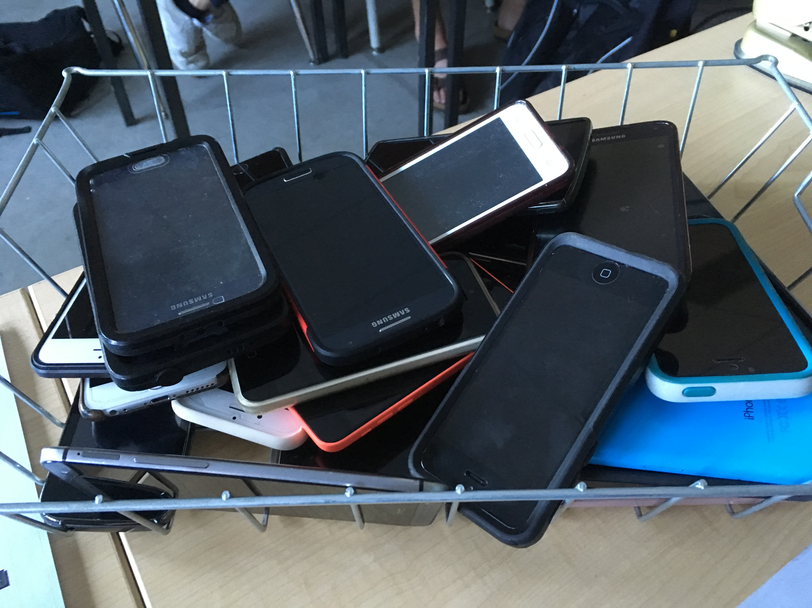

Total Score: _____

Social Responsibility Mark: _____

Work Ethic: _____

Social Responsibility

Criteria

- Do you hand in assignments on time?

- Do you put your hand up to ask a question?

- Do you use acceptable language/talking in class?

- Are you always on-time to class?

- Do you exemplify positive thinking and attitude?

- Do you show respect to their peers and me (ie. phone abuse)?

- Do you stay on task for the class (ie. do what you’re supposed to do?)

- Are you easily distracted by that person next to you, or do you distract them?

- Do you feel it’s your right to re-do outcomes?

- Do you miss class due to extra-curricular or “other” reasons….which tend to be unexcused?

- Do you ask: “can I leave early”?

- Do you use your phone in class for anything other than school work?

- By keeping your cell phone away, you are indicating that your learning is more important than your need to have a cell phone.

- I will evaluate your work ethic on this rubric by term's end. If you are receiving a low percentage, the cell phone count will show me you care about your learning, and as such your social responsibility mark will benefit your overall mark.

