Activating Student Accounts (Consent Process)

NOTE! Once parents/students complete the consent process, student accounts will be activated (ready for logging in) within 24hrs!

Below are the steps in getting your students access to their free and secure SD23 GSuite accounts (feel free to follow step-by-step or click on any of the hyperlinks to jump to that section):

Getting Your Students Signed Up
Consent Process for K-7 Students
Consent Process for Gr. 8-12 Students
Getting Your Students Logged In

Getting Your Students Signed Up
We recently completed a significant Privacy Impact Assessment on GSuite. As a result of this process, we have a differentiated approach (see table below) on how students can access and activate their own free and secure SD23 GSuite accounts.

K-7 Consent Process | Gr. 8-12 Consent Process
- Both parents and students need to complete the electronic GAFE Agreement form | - Only students need to complete the electronic GAFE Agreement form  - Parents/Guardians must be notified that their child is being provided access to a free and secure SD23 GSuite account

*Note: the electronic consent forms ask for parents/students to enter the student’s usual name (as listed in MyEdBC) and the student’s date of birth to access the form. Once entered, the form will be pre-populated with the student’s information. A copy of the completed consent form is automatically sent to the parent’s primary email address (as listed in MyEdBC) for both the K-7 and the Gr. 8-12 consent process.

Consent Process for K-7 Students
For students in grades K-7, they must complete the K-7 Digital Consent Process. This process includes BOTH the Parent/Guardian and the Student providing their signatures on the electronic consent form.

To get your K-7 students signed up:

- Send an email notice home to your K-7 parents/guardians, requesting they read and sign the electronic SD23 K-7 Student GAFE Agreement in order for their child to be provided an SD23 GSuite account.
  - Feel free to use/modify the following K-7 Email Template.
  - You can also use/modify the following K-7 Handout Template to send home instead if you wish.

- Use the GAFE Lookup Tool to track which students have completed the consent process and have been provided an SD23 GSuite account.
  - If you’d like an overview on how to use the GAFE Lookup Tool, please see the “Student Accounts” page on the SD23 GSuite Network website.

- If you have any parents/guardians with concerns about privacy/security/other, we encourage you to connect with them directly (ex. over the phone). You can use the following talking points and the following FAQ document to help answer their questions.
  - Note: concerns rarely arise from parents, but when they do, they are often misconceptions around privacy/security. Many parents only know about the wide-open Google service on the open web and may not understand that our SD23 GSuite accounts are quite different in that our district owns the data, there are no advertisements, there is no selling of data to third parties, and all data is secured up in the cloud.

Consent Process for Gr. 8-12 Students
For students in grades 8-12, they must complete the Gr. 8-12 Digital Consent Process. This process includes having the Student providing their signature on the electronic consent form, and the school sending home a notice to inform parents.

To get your Gr. 8-12 students signed up:

- Have your Gr. 8-12 students read and sign the electronic SD23 Gr. 8-12 Student GAFE Agreement in order to be provided an SD23 GSuite account (Note: students can access this link through the Dashboard in the GSuite Tools Tile).
  - We suggest doing this through either the library or your English classes (so it’s easier to track who has and who has not completed the consent process).

- Send an email notice home to your Gr. 8-12 parents/guardians, to notify them that their child is being provided access to a free and secure SD23 GSuite account
  - Feel free to use/modify the following Gr. 8-12 Email Template.

- You may wish to use the GAFE Lookup Tool to track which students have completed the consent process and have been provided an SD23 GSuite account.
  - If you’d like an overview on how to use the GAFE Lookup Tool, please see the “Student Accounts” page on the SD23 GSuite Network website.

- If you have any students (or parents/guardians) with concerns about privacy/security/other, we encourage you to connect with them directly (ex. over the phone). You can use the following talking points and the following FAQ document to help answer their questions.
  - Note: concerns rarely arise from student or parents, but when they do, they are often misconceptions around privacy/security. Many students/parents only know about the wide-open Google service on the open web and may not understand that our SD23 GSuite accounts are quite different in that our district owns the data, there are no advertisements, there is no selling of data to third parties, and all data is secured up in the cloud.

Getting Your Students Logged In
Once the student consent process is completed, students can now log into their SD23 GSuite accounts.

To help your students get started, you can visit the “Getting Started” page on the SD23 GSuite Network website. There is a section on “Student Accounts” with all the information you need to get your students started, including:

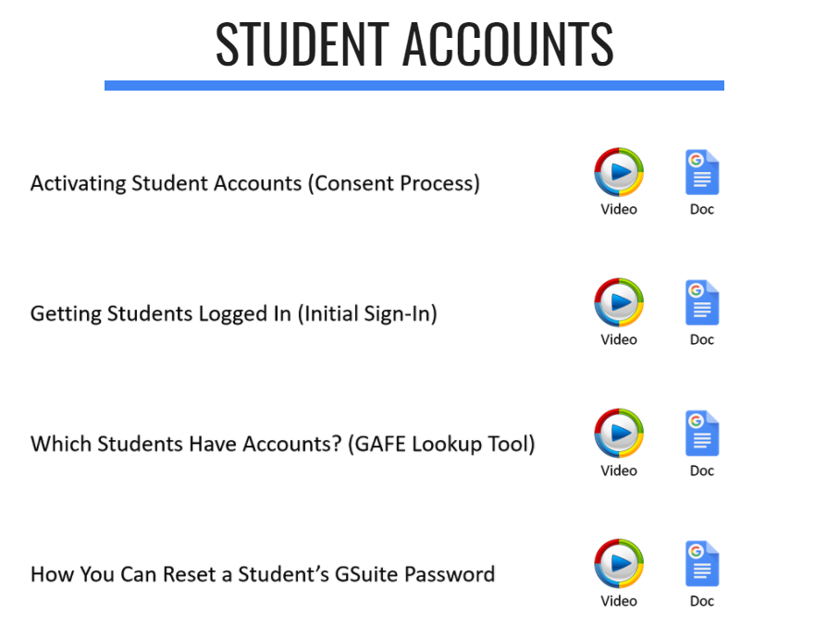

**If you have any further questions as your school is “Going Google”, please don’t hesitate to reach out to the Learning Technology Department**

